

**Interactive Restaurant Density Mapping using and IPython Documentation**

**Step 1 -** Installing **folium** module. You can do it inside Jupyter Notebook as shown below

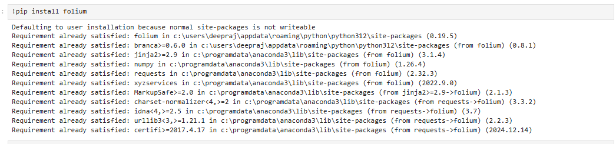

**Step 2 -** Installing **IPython** module. You can do it inside Jupyter Notebook as shown below

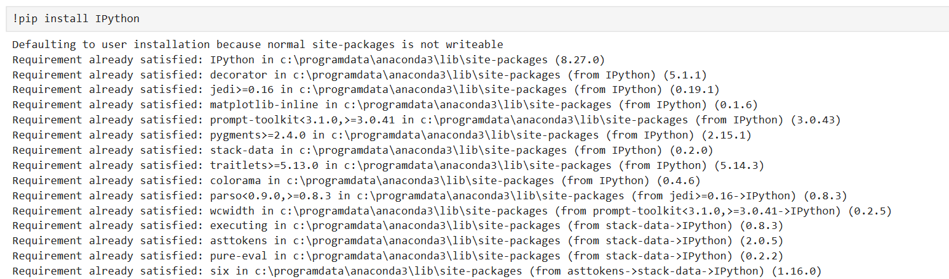

**Step3 -** Reading the csv data into a dataframe.

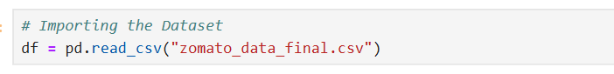

**Step 3 -** Import required library - **folium and IPython**

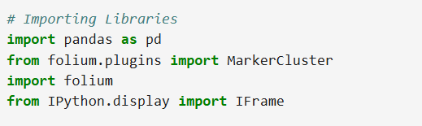

**Step 4 -** Restaurant Density Visualization using **Folium**

**1.Objectivec**

The main aim is to visualize restaurant locations on a map to understand their density in a city.

### **2.Map Initialization**

We start by creating a map centered on the city (e.g., Bangalore) using its latitude and longitude.

### **3. Add Marker Clustering**

To avoid overlapping markers, we use clustering. This groups nearby restaurants into clusters that can be clicked and zoomed into.

### **4.Plot Restaurant Data**

### We loop through the restaurant data and add a marker for each one with a valid latitude and longitude.

### **5.Show Restaurant Details**

Each marker displays a popup with details like:

* City name
* Restaurant rating
* Approximate cost for two people

### **6.Save the Map**

The map is saved as an HTML file so it can be opened and viewed in any browser.

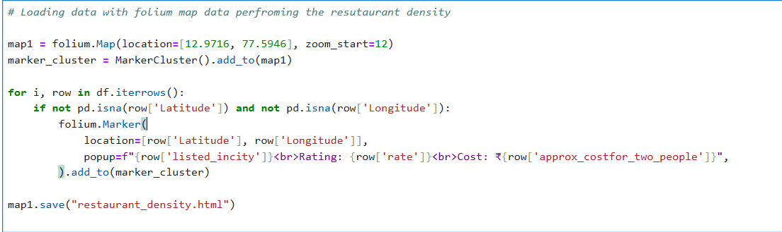

**Step 5-** Displaying the Map in a Notebook

### **1.Purpose**

To view the saved interactive restaurant density map directly within a Jupyter Notebook.

### **2.Use IFrame**

The IFrame function from IPython.display is used to embed the HTML file (restaurant_density.html) into the notebook.

### **3.Set Dimensions**

The width and height are specified to control how large the map appears in the output cell.

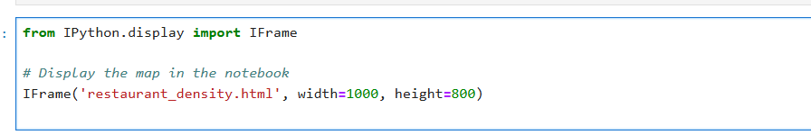

**Output**

